CANDIDATE ASSESSMENT REPORT
For: SEMBCORP
Re: Confidential
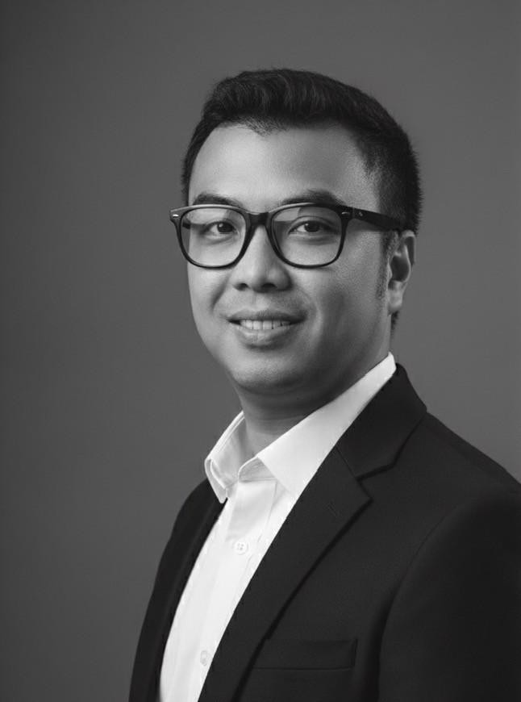
- Personal Details
Full name: Tran Nhat Quang
Gender: Male
Year of birth: 1983
Address: HCMC
- Navigos Search’s Assessment
- P&L-oriented business leader with full accountability for a ~$2.5 – 3M operation, currently leading overall business performance, commercial strategy, and operational execution in Vietnam as Managing Director and Legal Representative.
- Proven track record in building and scaling new business platforms, having established and grown the Vietnam presence for an industrial real estate developer, covering land acquisition, project development, leasing, and integrated facility operations.
- Experienced in leading multi-sites and cross-border teams, managing ~49 staff across Vietnam, Singapore, and Taiwan (including ~20 office staff in Vietnam and ~22 operational staff at project sites).
- Strong operational and service delivery background developed through leadership roles at international real estate consultancies, with deep exposure to project management, workplace solutions, and integrated facility services for multinational clients.
- Well-connected within Vietnam’s real estate and corporate occupier market, with the ability to engage developers, investors, and corporate clients while representing the business in industry and stakeholder communities.
- Package:
  - Current basic Salary in Gross: Will be disclosed later
  - 13th monthly salary (YES/NO): Yes
  - Allowances & Benefits: Yes
  - Performance/ KPIs bonus (Quarterly/Yearly): Yes
  - Expected basic Salary in Gross: Negotiable
- Required notice: 30 – 45 days
- Prepared by: Phuong Huynh - Consultant
March 17, 2026
- Resume of the Candidate
- CAREER SUMMARY
Mar 2022 - Present VIETLOG INDUSTRIAL (VLI)
Sep 2022 - Present Managing Director
Aug 2022 - Present Legal Representative
Mar 2022 - Aug 2022 Associate Director
Feb 2021 - Mar 2022 CBRE VIETNAM
Oct 2020 - Mar 2022 Director, Head of Project Management Services
Jan 2021 - Feb 2022 Board Member at Vietnam Green Building Council (VGBC)
Feb 2021 - Dec 2021 Project Director, Standard Chartered Bank for CBRE Vietnam
Mar 2014 - Sep 2020 CUSHMAN & WAKEFIELD
Apr 2018 - Sep 2020 Senior Project Manager
Mar 2014 - Mar 2018 Project Manager
Oct 2010 - Feb 2014 KINGSMEN CREATIVES LTD
Project Manager
Jul 2007 - Sep 2010 COGNIPLUS INTERIORS VIETNAM
Site Manager

- WORKING EXPERIENCES & QUALIFICATIONS IN DETAIL
  - Working Experience

Mar 2022 - Present VIETLOG INDUSTRIAL (VLI)
As Managing Director and Legal Representative at Vietlog Industrial, a subsidiary of Skymont Capital, Quang has been instrumental in establishing and growing the company's presence in Vietnam.

Sep 2022 - Present Managing Director
- Overseeing development and operations of VLI business in Vietnam, including business development, facility operations, and team building.
- Acquiring land, executing project development, procurement, leasing, and post-handover facility management.
- Accountable for P&L, financing, asset management, and tenant services (maintenance, cleaning, security).
- Representing VLI/Skymont Capital in the Vietnamese real estate community.

Aug 2022 - Present Legal Representative
- Ensuring legal compliance and representation for VLI in Vietnam.

Mar 2022 - Aug 2022 Associate Director
- Contributed to initial setup and strategic planning for VLI's entry into the Vietnamese market.
- Built up the professional team to growth the business in Vietnam
VLI Hung Yen Project
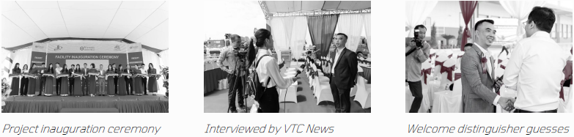

Feb 2021 - Mar 2022 CBRE VIETNAM
During his tenure at CBRE Vietnam, Quang - Director - played a pivotal role in establishing and leading the Project Management Services division, contributing significantly to its growth and profitability. Workig closely with CBRE’s Facility Management

Oct 2020 - Mar 2022 Director, Head of Project Management Services
- Established, developed, and led CBRE’s Project Management service business in Vietnam. Responsible for profitable P&L, team building, business development, and representing CBRE’s integrated project and facility services in the Vietnam real estate community.

Jan 2021 - Feb 2022 Board Member at Vietnam Green Building Council (VGBC)
- Represented CBRE on the VGBC board, contributing to sustainable building initiatives.

Feb 2021 - Dec 2021 Project Director, Standard Chartered Bank for CBRE Vietnam
- Managed entire consolidation workplace and property projects in Hanoi for Standard Chartered Bank, ensuring successful delivery and client satisfaction.
Impact at CBRE Vietnam
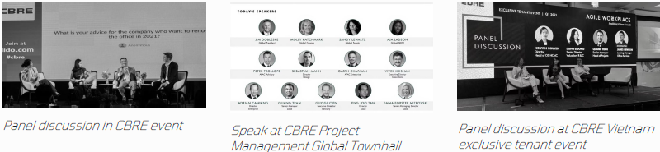

Mar 2014 - Sep 2020 CUSHMAN & WAKEFIELD
Quang's 6 years and 7 months at Cushman & Wakefield saw him rise from Project Manager to Senior Project Manager, where he honed his skills in comprehensive project oversight and client representation.

Apr 2018 - Sep 2020 Senior Project Manager
- Managed entire client projects, ensuring goals and objectives were achieved.
- Oversaw reports to clients and the company.
- Represented client interests throughout the project lifecycle and communicated with all stakeholders.
- Responsible for financial performance, budgeting, and achieving strategic business objectives.

Mar 2014 - Mar 2018 Project Manager
- Prepared and developed project plans and budgets.
- Managed coordination with consultants, contractors, and authorities.
- Ensured successful project completion within budget and timeframes.
- Developed detailed development plans and oversaw project execution.
- Assisted in developing the project management team.
- Managed procurement processes and oversaw construction programs.

Oct 2010 - Feb 2014 KINGSMEN CREATIVES LTD

Project Manager
- Developed project plans and schedules, coordinated projects.
- Set up and managed project teams, delegated and monitored work.
- Oversaw technical and architectural design, ensuring compliance with client and regulatory parameters.
- Managed project budgets and coordinated sub-consultants.
- Acted as the principal point of contact with clients.

Jul 2007 - Sep 2010 COGNIPLUS INTERIORS VIETNAM

Site Manager
- Planned projects effectively, ensuring adherence to requirements, specifications, and safety.
- Set up emergency plans and site facilities.
- Managed storage facilities and stock planning.
- Produced labor schedules and maintained project progress records.
- Managed all on-site sub-contractors and coordinated works.
- Advised and implemented cost savings.

  - Other information (if any)
Quang Tran is a passionate and seasoned leader with over 18 years of experience in Vietnam’s real estate and industrial facility development and management market, working for top-notch international developers, consultants, and service providers. His expertise spans real estate development, integrated facility operations, business development, P&L management, commercial strategy, and multi- site service delivery. He has a proven track record of building businesses from the ground up, managing large-scale operations, and leading diverse teams to reach new heights of success.
- Extensive Experience: 18+ years in international real estate development, facility operations, consulting, and service management.
- Leadership & Strategy: Proven ability to build and lead organizations, drive business growth, and manage P&L across multi-service operations.
- PMP Certified: Equipped with the latest global standards in project management (PMP® #1741488).
- MBA Certified: Holds an MBA in Business Administration from Columbia Southern University (Vietnam).

DIVERSE FUNCTIONAL EXPERTISE
Quang's background is diverse and extensive, covering a wide array of job functions critical to successful project delivery, facility operations, and intr
Project Lifecycle Management
- Real Estate Investment
- Business sourcing & M&A
- Planning & design
- Tendering/bidding management
- Cost estimation
- Construction management
Operational & Contractual Acumen
- Quality control
- Contract negotiation & management
- Innovative conception to triumphant handover
- Facility operations & aftersale services
This comprehensive skill set allows Quang to oversee projects from initial development through to ongoing facility operations and service delivery, ensuring seamless execution and long-term stakeholder satisfaction.

PROJECT PORTFOLIO ACROSS MULTIPLE SECTORS
Quang has overseen a wide range of projects across multiple sectors, demonstrating his versatility and capability in managing diverse real estate endeavors.
- Industrial Facilities: Industrial plant factories, ready-built warehouses, and BTS projects.
- Commercial Spaces: Commercial office and retail spaces, including fitting out.
- Hospitality Establishments: Management and development of hospitality projects.
- Residential Buildings: Construction of residential buildings.
From exciting new builds to dynamic renovations, Quang's experience covers the full spectrum of project types.

KEY AREAS OF EXPERTISE
Quang's expertise is multifaceted, covering critical aspects of project management, facility operations, and business leadership across real estate an
- Project Establishment and Development: Strategic project planning, risk, cost, and quality management, Value Engineering. Facility setup and operational readiness.
- Team & Stakeholder Management: Management of large multi-disciplinary teams and workforce. Client, vendor, and authority management. People development.
- Specialized Fit-Outs: Fitting out and managing commercial office spaces, retail spaces, banks, hospitality and industrial facilities.
- Sustainability & Safety: Sustainability management, environmental compliance, occupational health & safety management. Building services and operational standards.

ACHIEVEMENTS
Quang Tran's leadership has been consistently recognized through prestigious awards and certifications.
Great Leadership Award 2024
- Issued by British Chamber of Commerce Vietnam in June 2024.
- Presented by British Ambassador to Vietnam, H.E. Iain Frew.
- Recognizes outstanding management of the Vietlog Industrial Vietnam.
- Highlights commitment to top-tier leadership, experience, and knowledge at Vietlog.

KEY PROJECT EXPERIENCES
- VLI Hung Yen (Mar 2022– Mar 2023): associated with Vietlog Industrial. A 30 000 m² high-standard factory, warehouse and office for lease.
- Welco Technology Vietnam (Nov 2020 – Jun 2022): associated with CBRE Vietnam, managed the overall process, quantity services and site construction works for WELCO Technology’s new 28 500 m² electronic-production factory in Hai Duong (with food-service and canteen facilities).
- ZKG Mensa Industrial Factory (Jun 2018 – May 2019): associated with Cushman & Wakefield Vietnam, managed entire 11,000sqm project life cycle from initial stage to closing out of phase 1, including design – tender procurement – construction - close out.
- Standard Chartered Bank Hanoi consolidation office & branches fit-out project (Jan 2021 – Jun 2022): associated with CBRE Vietnam. Consolidation office project for a large commercial bank in Vietnam, including a 2 500 m² office and a 300 m² retail branch.
- Apple Ha Noi (Feb 2021 – Nov 2021): associated with CBRE Vietnam, A two-phase high-end office fit-out project (1 200 m²) in Ha Noi.
- Unilever Vietnam International (Aug 2018 – Jan 2020): associated with Cushman & Wakefield. 10 000 m² office renovation to transform their 10-year-old office into a modern agile working environment

NEWS & MEDIA
VLI Hung Yen - The world class industrial property in Hung Yen Province
- With the increasing demand for ready-built warehouses/factories that meet the conditions of export processing enterprises (EPEs), Vietlog Industrial promises to be a suitable destination thanks to its modern and flexible design to meet many different industries.READ MORE
Work starts on VLI's warehouse in northern Vietnam
- VLI, an affiliate of Hong Kong-based investment management company Skymont Capital, early this week broke ground for its VLI Warehouse Hung Yen project. VLI Warehouse Hung Yen will be a 29,000 square meter Grade A warehouse with modern standards.
Interview by Business Forum Magazine
- Discussed with Business Forum Magazine regarding the new trends in industrial real estate development for 2024
Vietlog Industrial breaks ground on Grade A warehouse project in Hung Yen
- “By applying international standards in construction quality and finishing for industrial warehouses, we are confident in delivering high-quality warehouse space to the market in Q1 2023, meeting the strong and growing demand from premium clients, especially in the logistics and e-commerce sectors in Northern Vietnam,” emphasized Mr. Quang Tran, representative of Vietlog Industrial Hung Yen in charge of project development.

